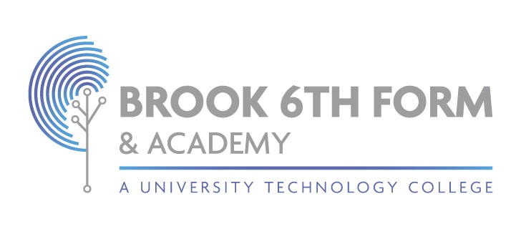

**Access to Scripts, Reviews of Results and Appeals Procedures (Exams)**

2024/25

This procedure is reviewed annually to ensure compliance with current regulations

|  |  |
| --- | --- |
| Approved/reviewed and signed by | |
| Name: Kim Donovan  Signature: | |
| Date of next review | September 24 |

# Access to Scripts, Reviews of Results and Appeals Procedures 2024/25

|  |  |
| --- | --- |
| Centre name | Brook Sixth Form & Academy |
| Centre number | 12802 |
| Date procedures first created | 16/05/2024 |
| Current procedures approved by | Kim Donovan |
| Current procedures reviewed by | Kim Donovan |
| Date of review |  |
| Date of next review | 01/09/2025 |

# Key staff involved in the procedures

|  |  |
| --- | --- |
| **Role** | **Name** |
| Head of centre | Kim Donovan |
| Senior leader(s) | Daniel  Buja, Einora Seiliute |
| Exams officer | Hayat Abuallan |
| Other staff (if applicable) |  |

These procedures are reviewed and updated annually to ensure that Brook Sixth Form & Academy deals with candidates‘ requests for access to scripts, clerical re-checks, reviews of marking, reviews of moderation and appeals to the awarding bodies in accordance with current requirements and regulations.

Reference in these procedures to GR and PRS refer to the JCQ documents **General Regulations for Approved Centres** and **Post-Results Services**.

# Introduction

Following the issue of results, awarding bodies make post-results services available.

The JCQ post-results services currently available are detailed below.

**Access to Scripts** (ATS):

* Copies of scripts to support reviews of marking
* Copies of scripts to support teaching and learning **Reviews of Results** (RoRs):
* Service 1 (Clerical re-check): This is the only service that can be requested for multiple choice tests
* Service 2 (Review of marking): This service is available for externally assessed components of both unitised and linear GCE A-level specifications, GCSE specifications and Level 1, 2 Vocational and Technical qualifications
* Priority Service 2 (Review of marking): This service is available for externally assessed components of both unitised and linear GCE A-level specifications and Level 3 Vocational and Technical qualifications. • Service 3 (Review of moderation): This service is not available to an individual candidate **Appeals**:
* The appeals process is available after receiving the outcome of a review of results

# Purpose of the procedures

The purpose of these procedures is to confirm how Brook Sixth Form & Academy deals with candidates‘ requests for access to scripts, clerical re-checks, reviews of marking, reviews of moderation and appeals to the awarding bodies in compliance with JCQ regulations (GR 5.13).

Details of these procedures are made widely available and accessible to all candidates by: Procedure is available to all students and parents via school website.

# The arrangements for post-results services

* Candidates must be made aware of the arrangements for post-results services prior to the issue of results (GR 5.13)
* A review of moderation cannot be undertaken upon the work of an individual candidate or the work of candidates not in the original sample (PRS 4.3)
* The appeals process is available after receiving the outcome of a review of results (PRS 5.1) At Brook Sixth Form & Academy:
* Candidates are made aware of the arrangements for post-results services prior to the issue of results
* Candidates are also informed of the periods during which senior members of centre staff will be available immediately after the publication of results so that results may be discussed, and decisions made on the submission of reviews of marking (GR 5.13, PRS 4.1) Candidates are made aware/informed by:
* an exam assembly verbally and written communication to parents.

Full details of the post-results services, internal deadline(s) for requesting a service and the fees charged (where applicable) are provided by:

* Exams Officer
* following the issue of results

# Dealing with requests

* All post-results service requests from internal candidates must be made through the centre (GR 5.13) At Brook Sixth Form & Academy the process to request a service is:
* by completing a Post-results services: request, consent and payment form available from the exams officer.

# Candidate consent

* Candidates must provide their **written consent** for clerical re-checks, reviews of marking, and any subsequent appeal, and access to scripts services offered by the awarding bodies **after** the publication of examination results (GR 5.13)

(As applicable, it will be ensured that any private candidates are made aware that all post-results service requests can be made directly through the relevant awarding body) Brook Sixth Form & Academy will:

* Acquire written candidate consent (accepting informed consent via candidate email) in all cases before a request for a clerical re-check, a review of marking, and any subsequent appeal, or an access to scripts service request is submitted to the awarding body
* Acquire informed candidate consent to confirm the candidate understands that the final subject grade and/or mark awarded following a clerical re- check or a review of marking, and any subsequent appeal, may be lower than, higher than, or the same as the result which was originally awarded
* Only collect candidate consent **after** the publication of results
* Retain consent forms or e-mails from candidates for at least six months following the outcome of a clerical re-check or review of marking or any subsequent appeal (PRS 4.2)
* Retain consent/permission forms or e-mails from candidates to request and use their scripts for at least six months (PRS Appendix B)

Additional centre-specific actions:

# Submitting requests

Brook Sixth Form & Academy will:

* Submit requests electronically for clerical re-checks, reviews of marking, reviews of moderation and access to scripts by the published deadline(s) in accordance with the JCQ document **Post-results services** (GR 5.13)
* Submit requests for appeals in accordance with the JCQ document **A guide to the awarding bodies’ appeals processes** (GR 5.13)
* Confirm the awarding body's acknowledgement of receipt of a review of results request prior to the deadline for submission of post-results services and regularly check the progress of the request online (PRS 4.5)

Additional centre-specific actions:

# Dealing with outcomes

Brook Sixth Form & Academy will:

* Ensure outcomes of clerical re-checks, reviews of marking, reviews of moderation and appeals are made known to candidates as soon as possible (GR 5.13) Candidates will be notified by:
* being emailed a copy of the outcome notification from the awarding body, etc.

Additional centre-specific actions:

# Managing disputes

At Brook Sixth Form & Academy any dispute/disagreement will be managed in accordance with the internal appeals procedure to manage disputes when a candidate disagrees with a centre decision not to support an application for a clerical re- check, a review of marking, a review of moderation or an appeal (GR 5.13).

Additional centre-specific actions:

# Changes 2024/2025

(Updated) Under the heading **Reviews of Results** (RoRs), Service 2 and Priority Service 2 qualification details updated.

(Updated) Under the heading **Candidate consent**: Bullet points updated:

* Candidates must provide their written consent for clerical re-checks, reviews of marking, and any subsequent appeal, and access to scripts services offered by the awarding bodies after the publication of examination results (GR 5.13) (As applicable, it will be ensured that any private candidates are made aware that all post-results service requests can be made directly through the relevant awarding body)
* Acquire written candidate consent (accepting informed consent via candidate email) in all cases before a request for a clerical re-check, a review of marking, and any subsequent appeal, or an access to scripts service request is submitted to the awarding body

# Centre-specific changes