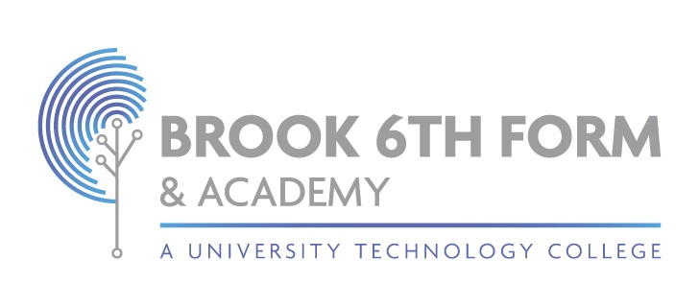

**Candidate Identification Procedure (Exams)**

2024/25

This procedure is reviewed annually to ensure compliance with current regulations

|  |  |
| --- | --- |
| Approved/reviewed and signed by | |
| Name: Kim Donovan  Signature: | |
| Date of next review | September 24 |

# Candidate Identification Procedure

|  |  |
| --- | --- |
| Centre name | Brook Sixth Form & Academy |
| Centre number | 12802 |
| Date procedure first created | 16/05/2024 |
| Current procedure approved by | Kim Donovan |
| Current procedure reviewed by | Kim Donovan |
| Date of review |  |
| Date of next review | 01/09/2025 |

# Key staff involved in the procedure

|  |  |
| --- | --- |
| **Role** | **Name** |
| Head of centre | Kim Donovan |
| Senior leader(s) | Kim Donovan, Daniel Buja, Einora Seiliute |
| Exams officer | Hayat Abuallan |
| Other staff (if applicable) |  |

This procedure is reviewed and updated annually to ensure that procedures to verify the identity of all candidates that are entered for examinations or assessments at Brook Sixth Form & Academy are managed in accordance with current requirements and regulations.

References in this procedure to GR and ICE refer to the JCQ documents **General Regulations for Approved Centres** and **Instructions for conducting examinations**.

# Purpose of the procedure

The purpose of this procedure is to confirm that Brook Sixth Form & Academy:

* verifies the identity of all students that it enters for examinations or assessments (GR 5.6)
* has processes in place to be satisfied that all candidate identities have been checked (GR 5.6)
* has written procedures in place to verify the identity of all candidates at the time of the examination or assessment (GR 5.9)

# Process to check candidate identity

## Internal candidates

The identity of students on roll at Brook Sixth Form & Academy is checked as part of the initial registration process. (GR 5.6) The process is:

• Students identity is checked during admissions process where parent/carer is required to provide a birth certificate or a passport.

## Private candidates

The identity of any student who has not received any tuition at Brook Sixth Form & Academy but who may be accepted to enter examinations as a private candidate will be checked by a verification process which involves photo-ID. (GR 5.6)

At Brook Sixth Form & Academy:

• We do not accept private candidates.

# Procedure detailing how the identity of all candidates sitting examinations is confirmed

Invigilators are able to establish the identity of all candidates sitting examinations in accordance with this procedure and by following the arrangements in place for them to carry out adequate checks. (ICE 16) The process at Brook Sixth Form & Academy is:

* Invigilators are support by senior leadership and exam staff in identifying the students at the time of the assessment/exam.

The following arrangements are also in place:

* A private/external candidate or a transferred candidate who is not known to the centre will be asked to show photographic documentary evidence to prove that they are the same person who entered/registered for the examination/assessment, e.g. a passport or photographic driving licence (ICE 16.5)
* Where it is impossible to identify a candidate due to the wearing of religious clothing, such as a veil, the candidate will be approached by a member of staff of the same gender and taken to a private room where they will be politely asked to remove the religious clothing for identification purposes (ICE 16.6)
* Invigilators will be informed of those candidates with access arrangements and made aware of the access arrangement(s) awarded (ICE 16.8)

# Roles and responsibilities

## The role of the exams office/officer

* Through training, ensure invigilators are aware of the procedure for confirming the identity of all candidates sitting examinations (ICE 16.1)
* Prior to the examination, inform a private/external candidate or a transferred candidate who is not known to the centre that they must show photographic documentary evidence to prove that they are the same person who entered/registered for the examination/assessment, e.g. passport or photographic driving licence. (ICE 16.5)
* Inform candidates prior to their first examination that where it is impossible to identify a candidate due to the wearing of religious clothing, such as a veil, the candidate will be approached by a member of staff of the same gender and taken to a private room where they will be politely asked to remove the religious clothing for identification purposes and that once identification has been established, the candidate should replace, for example, their veil and proceed as normal to sit the examination (ICE 16.6)
* Prior to the beginning of the examination, brief invigilators on those candidates with access arrangements and make them aware of the access arrangement(s) awarded (ICE 16.8)

Additional responsibilities:

# Changes 2024/2025

(Updated) References to sections of ICE 16 where these have been changed in ICE 2024-2025.

(Changed) Heading **Procedures to verify candidate identity at the time of the examination/assessment** to **Procedure detailing how the identity of all candidates sitting examinations is confirmed** to reflect the re-wording in ICE 16.1.

(Updated) Various bullet points to reflect slight wording changes in various sections of ICE 16.

# Centre-specific changes