Monday, December 2nd, 2024

Dear Parent / Carer,

**Year 12 Parents’ Evening – Thursday 12th December 2024**

On Thursday 12th December 2024, all KS5 staff will be available to discuss the progress of your child at the end of their first term at Brook 6th Form. This will enable you to gain an understanding on how they are doing in their separate subjects, and their teachers will be able to give further guidance and strategies to ensure that your child continues to make progress in their learning and is prepared for the next stages of their courses.

The Parents’ Evening will run from 4:00pm until 6:00pm at Brook. Each staff member will liaise with your child to make an appointment to see them at the evening. Can you please discuss with your child the times that you are available and ensure that they make the appointments with all their subject teachers?

The students will all be given an appointment sheet to complete. These evenings are an important event for us to meet with you and build the relationship to support them through their course and time at Brook.

If you are unable to attend the evening, would you please let me know as soon as possible so that I can notify all the staff.

If you would like to discuss this matter further, then please do not hesitate in contacting me at c.bannister@brooksixthform.com and I look forward to seeing you all on Thursday 12th December 2024.

Yours Sincerely,

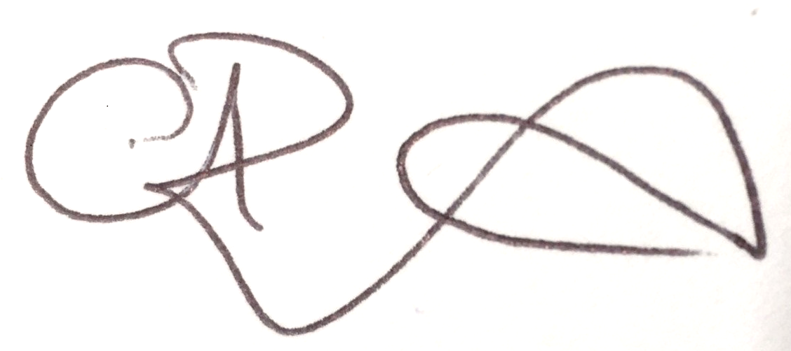

Claire Bannister

Assistant Principal

