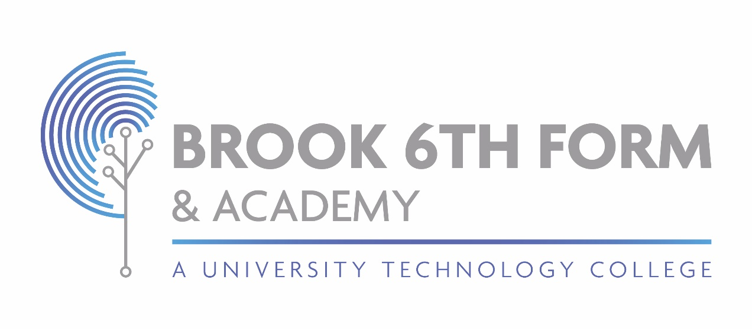

SEND Report

Information regarding SEND Provision at Brook 6th Form & Academy

December 2023

**Schedule 1 Information**

The following information is broken down into sections in line with Schedule 1, Regulation 51 of the Special Educational Needs (Information) Regulations in the Children and Families Act 2014.

**Educational Needs Provided for by the Academy**

Brook 6th Form & Academy defies Special Educational Needs as any student who has any barrier that hinders their access to a standard differentiated curriculum. This includes those who have a significantly greater difficulty in learning and significantly slower progress than their peers, or have a disability that prevents or hinders them from making use of our educational facilities.

Brook 6th Form & Academy provides for a number of students with a range of difficulties. These include:

* Communication and Interaction
* Social, Emotional and Mental Health Difficulties
* Cognition and Learning
* Sensory and/or physical

**The assessment and identification of pupils with SEND**

Brook 6th Form & Academy will adopt a graduated response to meeting special educational needs that requires the initial use of classroom and UTC resources before bringing specialist expertise to bear on the difficulties that a student is experiencing. When a student is identified as having a special educational need, Brook 6th Form & Academy will intervene as outlined in the SEND Policy. Such interventions are a means of helping Academies and Parents/Carers match special educational provisions to individual student needs.

**Information on meeting the needs of the students.**

All students, including those with SEND, are assessed on a regular basis, in accordance with the Assessment policy for the Academy. Teachers formally assess and review progress and attainment which is communicated to parents/carers by a report which is sent home, three times a year. Additionally, Parent’s evenings are held, where there is an opportunity to discuss progress, attainment and any next steps to further improve progress. All students with an EHCP have an annual review with the SENCO.

The Academy has a teacher observation process that assesses the effectiveness of Teaching and Learning for all students, including those with SEND, and the outcomes of these evaluations are used to create and implement development plans for all aspects of Academy life. These are regularly reviewed and evaluated.

The progress made by all students is regularly monitored and reviewed by teachers and members of the Senior Leadership Team. Initially, concerns are registered by teachers, parents/carers or other agencies and these concerns are addressed by appropriate differentiation within the classroom and a record is kept of strategies used. This is on a student’s pupil passport.

When a student is found not to make sufficient progress, despite high quality teaching, the SENCO, teacher, parent/carer and child should assess whether the child has any area of SEND and gather the appropriate evidence. A child is considered to have SEN if they fit into one or more of the four broad areas of need listed above.

In a very few cases, if a student continues to demonstrate significant cause for concern despite interventions applied, a request may be made to the Local Authority for an EHCP Assessment.

This will decide the nature of the provision necessary to meet the students’ SEND. If this cannot reasonably be met by Brook 6th Form and Academy, then the Local Authority may provide extra resources.

**Brook 6th Form and Academy approach to teaching pupils with SEN.**

The staff at Brook 6th Form and Academy have high expectations of all students, including those with SEND. All teachers will be informed of a child’s individual need through the Pupil Passport and will adapt their lessons to meet these requirements. This may involve using different strategies, more practical/adaptation of resources and activities. This means that a child can access each lesson completely. The staff at Brook 6th Form and Academy have experience and/or are trained in these techniques, as well as receiving the ongoing support of the SENCO and the Senior Leadership Team.

Within the Academy, there are a variety of staff roles to help fully support the child. Where it is felt it is the right thing to do, a student may be offered additional help and support, in which case parent/carers will be informed of this decision. There are range of interventions and additional subject support which are available and, should your child require this, it would be discussed with the parent/carer.

Brook 6th Form and Academy will assess and apply for exam Access Arrangements according to the Joint Council for Qualifications exam regulations.

**Brook 6th Form and Academy adaptations to improve access for SEN learners**

Most of the students at Brook 6th Form and Academy follow a traditional curriculum, however a small number of learners have a more personalised curriculum to match their needs, interests and abilities. This may include; additional literacy and reading groups or 1:1 as well as intervention groups for specific subjects.

Brook 6th Form and Academy is a safe and accessible building and it is a welcoming place to be for the whole community. All safeguarding procedures and risk assessments are in place and adhered to by all staff. Brook 6th Form and Academy have a range of different facilities to help SEND students throughout the Academy including a lift to access all floors, disabled toilets, ramps, wide corridors and equipment to help with reading and writing.

**Brook 6th Form and Academy additional support**

Brook 6th Form and Academy have a wide range of staff to support the students and address any addition needs they may have, including students with SEND.

Resources are allocated based upon evidence of need and effectiveness. Students with an EHCP have resources allocated as outlined within their plan and in agreement with the parent/carers. The Learning Support Assistant will be allocated for support, where resources allow, to support students within their lessons and also on 1:1 basis for reading intervention. Staff at Brook 6th Form and Academy liaise closely with each other and the SENCO to ensure that there are a range of skills to offer in supporting students directly and indirectly too.

Students with EHCP’s will have targets and strategies set by agreement with their parent/carers, the Local Authority and the Academy. Annual reviews, involving the student, parent/carers and other professionals, occur to evaluate the targets and strategies. The decision is based upon evidence of need and impact.

Students who ned support in increasing their reading age have allocated time to read to the Learning Support Assistant once a week. This is monitored and impact measured.

**Available Additional Activities**

A large range of academic and interest clubs are available at Brook 6th Form and Academy as part of the Academy offer. These clubs and activities are open to all students, including those with Send.

Day trips are open to all students and a child’s additional need will not be a barrier to them accessing he trip or event.

Coursework and revision sessions will be available to all students, including those with SEND at Brook 6th Form and Academy.

**Support students with emotional or social needs**

There are members of staff who are able to provide pastoral support throughout the Academy day. The Academy currently uses a range of outside agencies to support with any aspect of emotional or social need, namely; Spark2Life, CAMHS, School Nurse, Academy Police Liaison Officer and the Local Authority Attendance Officer.

**Who do we need to contact?**

If you think that your child has a Special Educational Need, please contact the SENCO. The SENCO for Brook 6th Form and Academy is Magdarlyn Williams and they can be contacted at [m.williams@brooksixthform.com](mailto:m.williams@brooksixthform.com)

The SENCO is responsible for:

* Determining the strategic development of the SEND policy and provision at Brook 6th Form and Academy with the ultimate aim of raising the achievement of students with SEND need
* Collaborating with SENCOs in other partner schools and Nationally with other UTC’s in order to facilitate joint policies, and ensure the maximisation of expertise, resources and mutual support.
* Liaising with and advising colleagues on all matter s relating to SEND
* Contributing to the continuing professional development and training of Brook 6th Form and Academy staff
* Overseeing the day to day operation of Brook 6th Form and Academy’s SEND policy
* Co-ordinating provision for SEND Students
* Managing the SEND Learning Support Assistant on a daily basis
* Liaising with parents/carers on SND students in co-operation with the form and subject teachers as appropriate
* Liaising with external agencies including the Local Authority officer with responsibility for SEND and the educational psychology service, health and children’s services, voluntary bodies and others as appropriate.

For any information required around the areas of Safeguarding and Inclusion, you can contact the Assistant Principal, Mark Lewis at [m.lewis@brooksixthform.com](mailto:m.lewis@brooksixthform.com) who is also the Designated Safeguarding Officer for the Academy.

**Training of staff at Brook 6th Form and Academy**

The SENCO is training for the National SENCO Award and all training is provided to all staff, including teachers and support staff, as the need arises throughout the academic year. There is ongoing training for all staff as well as further opportunities to develop skill s and knowledge further.

Staff who are new to the Academy, follow an induction programme which includes training and information on SEND students.

As an Academy, we can call on the support from the consultant and specialist organisations from within the Local Authority as well as Health and Social Care Services.

**Equipment and Facilities at Brook 6th Form and Academy**

Brook 6th Form and Academy can access a range of services from within the local area. These services are contacted when it is necessary and appropriate to do so, according to a child’s specific need. If a child needs specialist equipment or other facilities, then a discussion with the SENCO and parent/carers is required.

**Consulting with Parents/Carers**

As part of the regular review procedure, students on the SEND Register will regularly receive feedback on their own progress and this is further fed back to parents/carers for their comments. Brook 6th Form and Academy also welcome opportunities to work with parent/carers and should anyone wish to discuss issues regarding any student, a meeting with the SENCO will be arranged.

**Consulting with Children**

As part of the regular review procedure, students on the SEND Register will regularly feedback on their own progress and how they feel their support is proceeding.

SEND students with an EHCP submit their views in writing as part of their annual review as well as to attend the review itself. Students and parents contribute to the setting of their own targets and strategies and is an important part if the EHCP and target setting for SEND.

**Complaints Procedure regarding SEND Provision at the Academy**

Concerns and complaints are dealt with in line with Brook 6th Form & Academy’s Complaints Procedure. Any initial concern should be raised with the SENCO, Ms M. Williams.

**Transferring between Schools**

Information regarding procedures and time scales for students wishing to attend Brook 6th Form & Academy are covered by our admission policy. If a student has a specific need that they wish to discuss prior to taking up a place, please contact the SENCO to make an appointment.

After joining Brook 6th Form & Academy, information from the application for is processed to produce an initial SEND register. School files are requested for those joining the Academy and needs are identified wherever possible. Further cross-school testing will be used in order to make sure that no pupil is ever disadvantaged by changing school and that all needs are identified as early as possible. As we get to know pupils, the information will be updated and this will then for the final SEND Register.

**The Local Authority’s Local Offer**

At Brook 6th Form & Academy, we are privileged to have pupils from a large catchment area. This means that we currently work with four different Local Authorities, each of which service a different area and provide different services, known as the Local Offer. In order to find out which other services are available to support your child or family, please contact your own Local Authority. Further guidance can be found at <https://www.lbbd.gov.uk/children-young-people-and-families/local-offer> for residents of Barking and Dagenham.